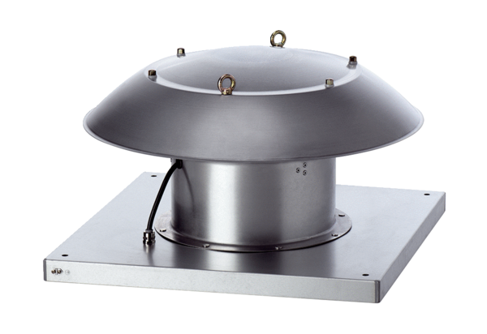Axial roof fan DZD 40/6 B Ex ePacking unit: 1 pieceRange: C
Article number: 0087.0804Manufacturer: MAICO

