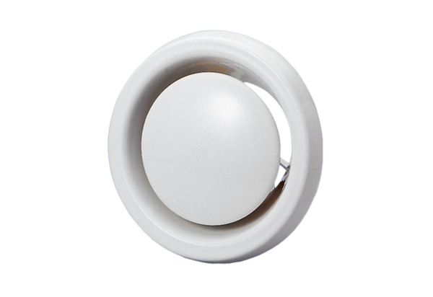Disk valve, fire protection TB 12Packing unit: 1 pieceRange: C
Article number: 0151.0271Manufacturer: MAICO

