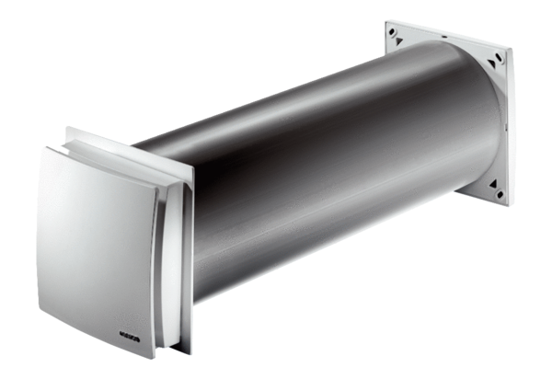Outside air opening ALD 160 VAPacking unit: 1 pieceRange: B
Article number: 0152.0070Manufacturer: MAICO

