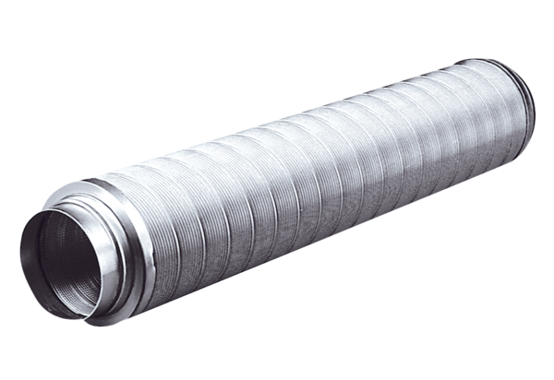Tubular sound absorber RSR 8Packing unit: 1 pieceRange: C
Article number: 0092.0310Manufacturer: MAICO

