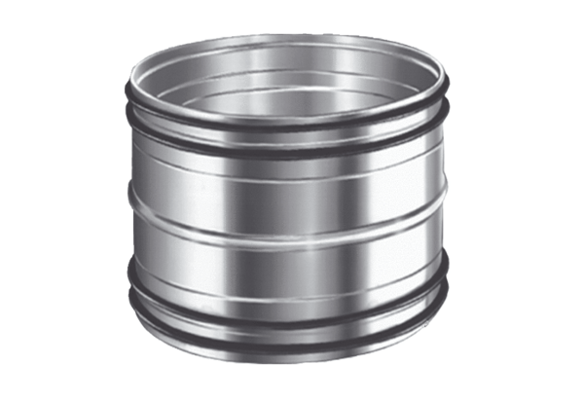Plug connectors for ducts SVR 125Packing unit: 1 pieceRange: K
Article number: 0055.0183Manufacturer: MAICO

