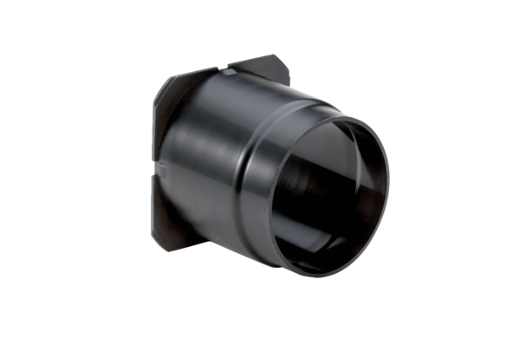Air extraction socket ER-ASPacking unit: 1 pieceRange: B
Article number: 0093.0928Manufacturer: MAICO

