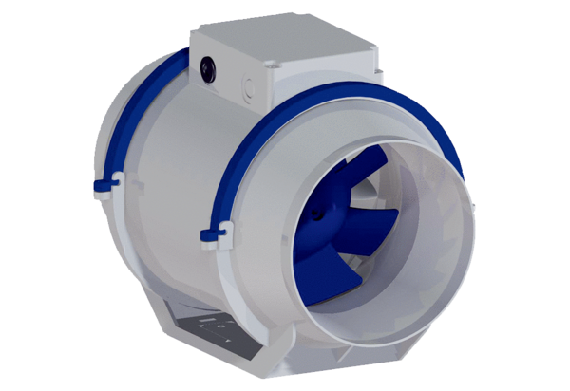Diagonal fan HDR 10Packing unit: 1 pieceRange: C
Article number: 0080.0536Manufacturer: MAICO

