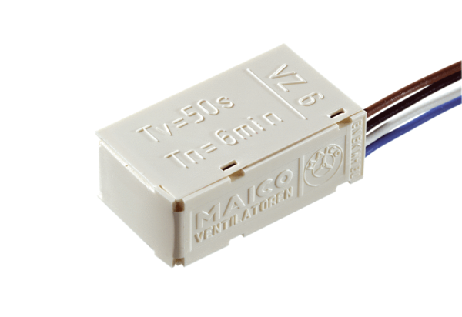Time delay switch VZ 6Packing unit: 1 pieceRange: A
Article number: 0157.0820Manufacturer: MAICO

