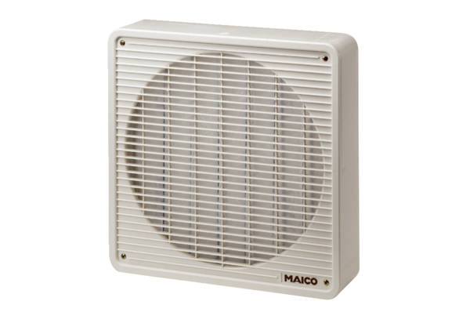Air filter ZFF 30Packing unit: 1 pieceRange: C
Article number: 0149.0003Manufacturer: MAICO

