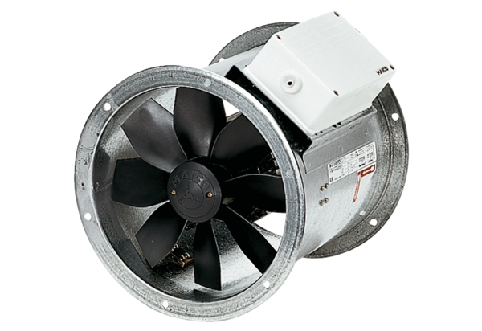Axial duct fan DZR 50/6 BPacking unit: 1 pieceRange: C
Article number: 0086.0034Manufacturer: MAICO

