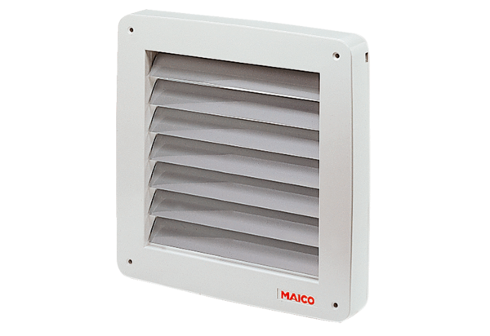Shutter, electric MK 25Packing unit: 1 pieceRange: C
Article number: 0093.0907Manufacturer: MAICO

