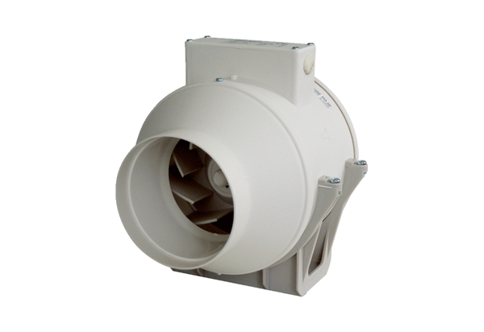Diagonal fan ERK 100 TPacking unit: 1 pieceRange: C
Article number: 0080.0174Manufacturer: MAICO

