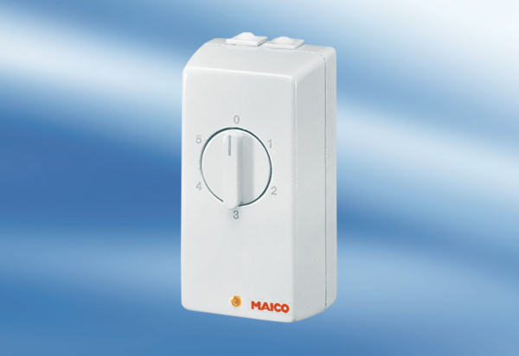TRE 0,6Packing unit: 1 pieceRange: C
Article number: 0016.0111Manufacturer: MAICO

