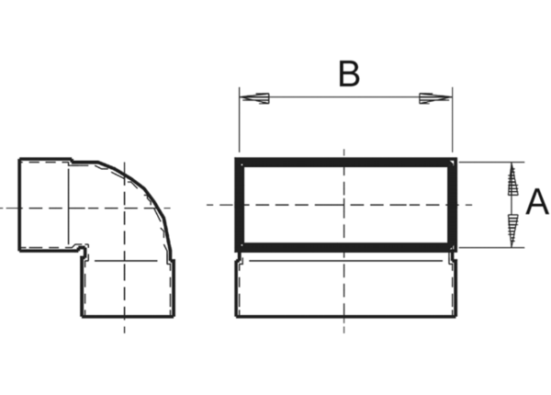90° channel elbows, short, vertical KB90KV/55/220Packing unit: 1 pieceRange: K
Article number: 0055.0595Manufacturer: MAICO

