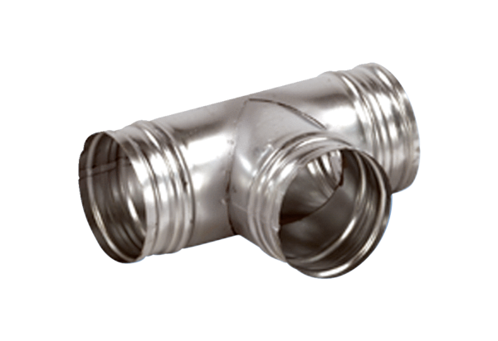90° branch AB 180-180Packing unit: 1 pieceRange: K
Article number: 0055.0379Manufacturer: MAICO

