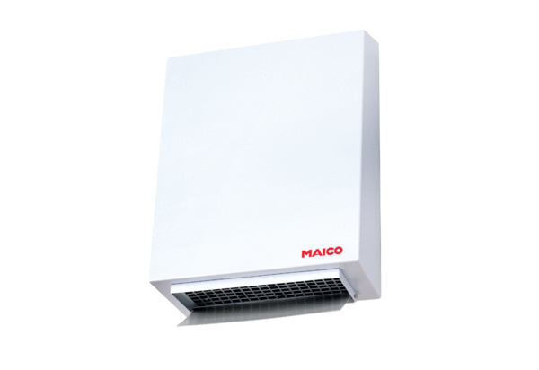Centrifugal external wall fan AWV 15Packing unit: 1 pieceRange: C
Article number: 0080.0996Manufacturer: MAICO

