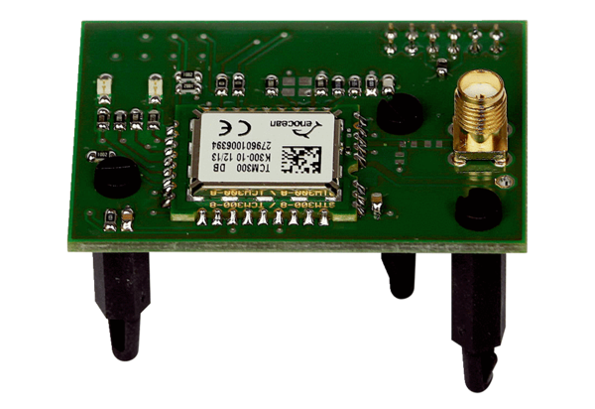EnOcean plug-in module E-SMPacking unit: 1 pieceRange: K
Article number: 0092.0556Manufacturer: MAICO

