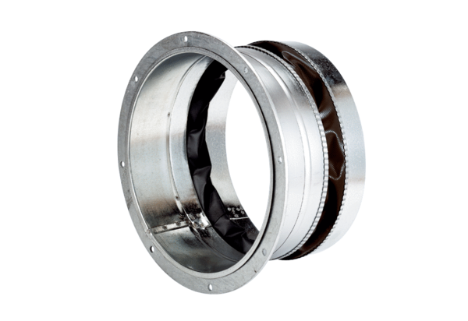Flexible coupling ELA 40 ExPacking unit: 1 pieceRange: C
Article number: 0092.0278Manufacturer: MAICO

