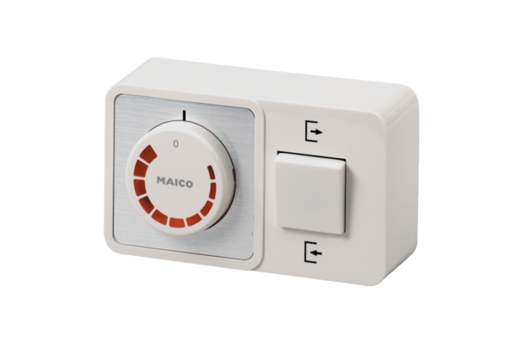Speed controller, reversing switch STW 2,5Packing unit: 1 pieceRange: C
Article number: 0016.0142Manufacturer: MAICO

