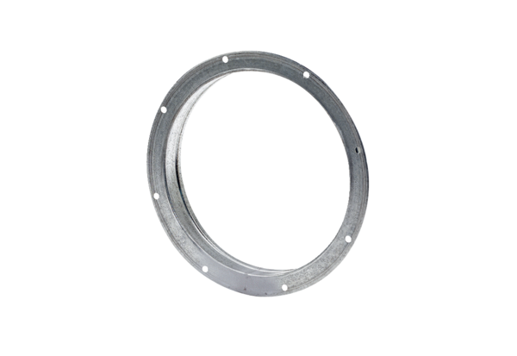Counter socket GS 45Packing unit: 1 pieceRange: C
Article number: 0055.0173Manufacturer: MAICO

