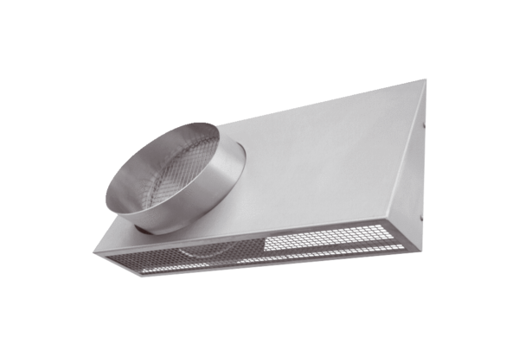Combi-wall connections KWH 12 RPacking unit: 1 pieceRange: K
Article number: 0152.0058Manufacturer: MAICO

