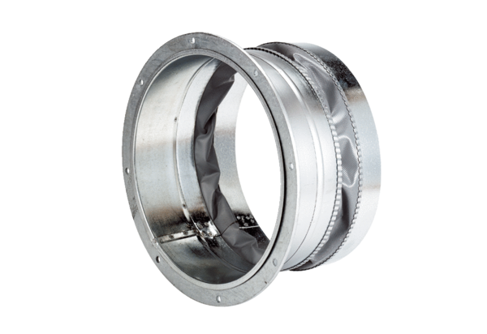Flexible coupling ELA 45Packing unit: 1 pieceRange: C
Article number: 0092.0270Manufacturer: MAICO

