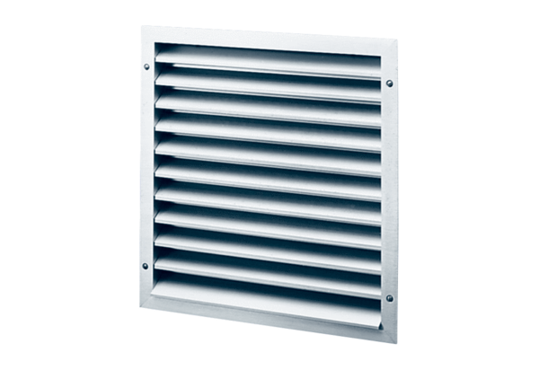External grille MLZ 40Packing unit: 1 pieceRange: C
Article number: 0151.0105Manufacturer: MAICO

