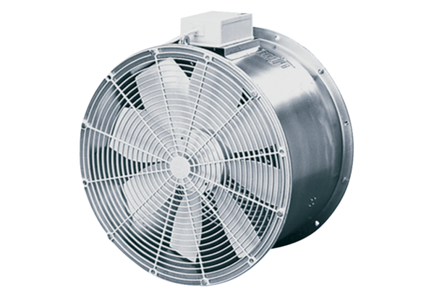Axial greenhouse fan EZG 30/4 BPacking unit: 1 pieceRange: C
Article number: 0085.0150Manufacturer: MAICO

