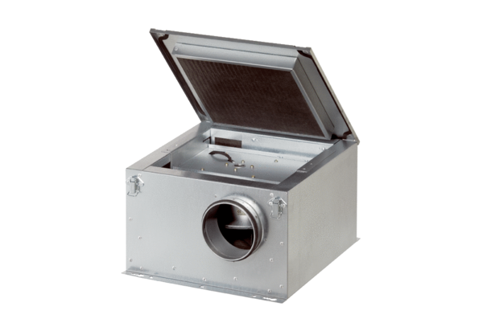Sound-insulated ventilation box ESR 12-2Packing unit: 1 pieceRange: C
Article number: 0080.0610Manufacturer: MAICO

