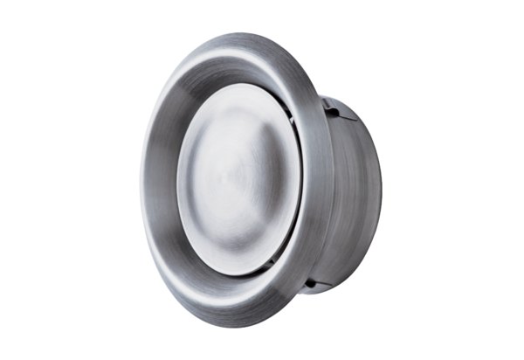Disk valve, stainless steel TM-V2A 10Packing unit: 1 pieceRange: C
Article number: 0151.0374Manufacturer: MAICO

