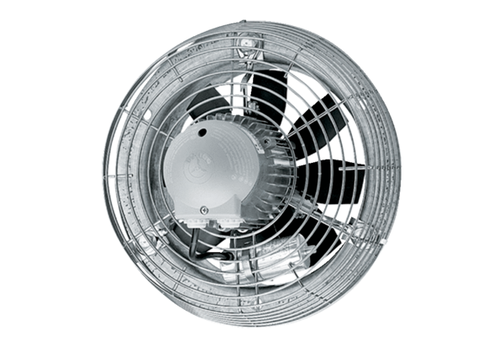Axial wall fan DZS 30/6 BPacking unit: 1 pieceRange: C
Article number: 0094.0014Manufacturer: MAICO

