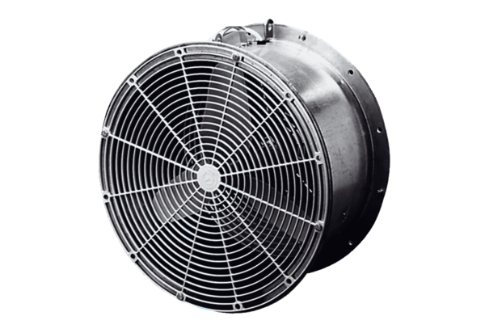Greenhouse fan EFG 40 DPacking unit: 1 pieceRange: C
Article number: 0081.0407Manufacturer: MAICO

