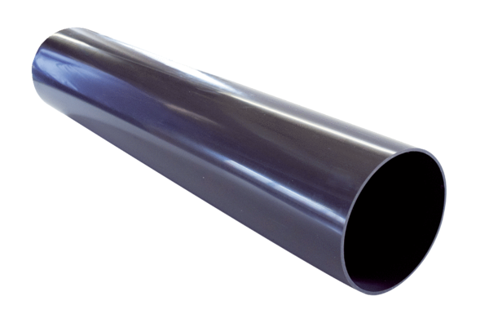Roof outlet sleeve PP 45 DFHKPacking unit: 1 pieceRange: K
Article number: 0059.0868Manufacturer: MAICO

