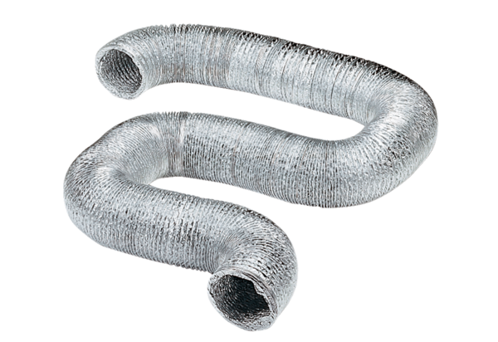Flexible aluminium duct AFR 150Packing unit: 1 pieceRange: C
Article number: 0055.0093Manufacturer: MAICO

