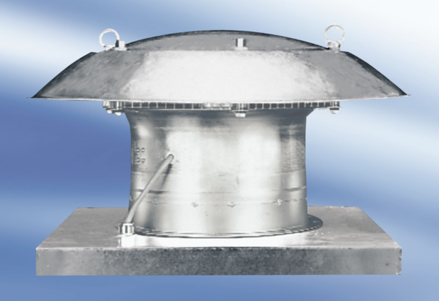Axial roof fan EZD30-6APacking unit: 1 pieceRange:
Article number: 0087.0403Manufacturer: MAICO

