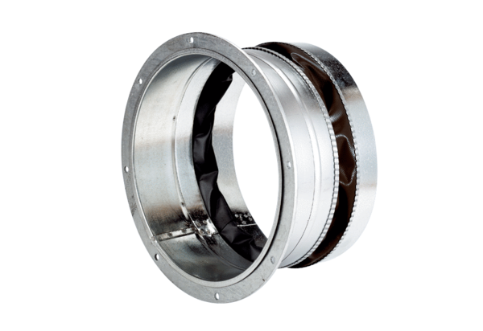Flexible coupling ELA 31 ExPacking unit: 1 pieceRange: C
Article number: 0092.0285Manufacturer: MAICO

