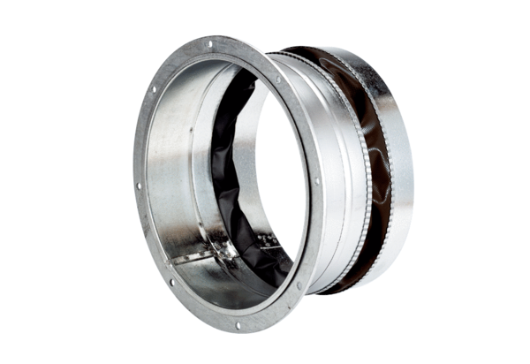Flexible coupling ELA 60 ExPacking unit: 1 pieceRange: C
Article number: 0092.0281Manufacturer: MAICO

