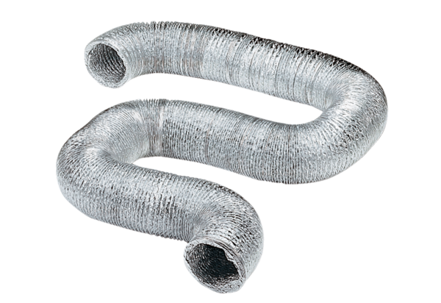Flexible aluminium duct AFR 75Packing unit: 1 pieceRange: B
Article number: 0055.0088Manufacturer: MAICO

