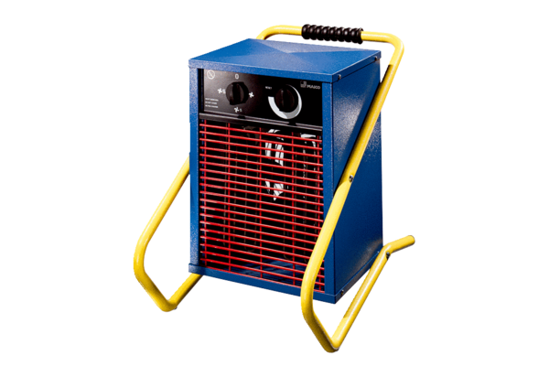Heater fan MHE 3Packing unit: 1 pieceRange: C
Article number: 0082.0200Manufacturer: MAICO

