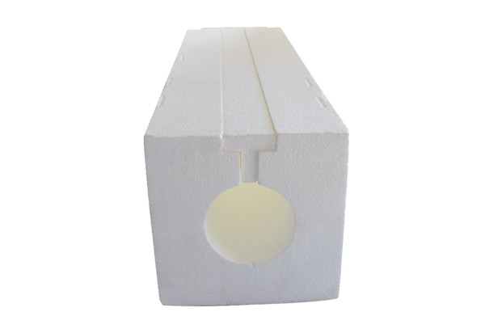Roof outlet duct PP 45 DFKPacking unit: 1 pieceRange: K
Article number: 0058.0096Manufacturer: MAICO

