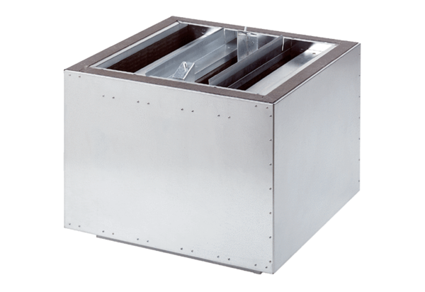Exhaust air silencer SDA 18Packing unit: 1 pieceRange: C
Article number: 0092.0385Manufacturer: MAICO

