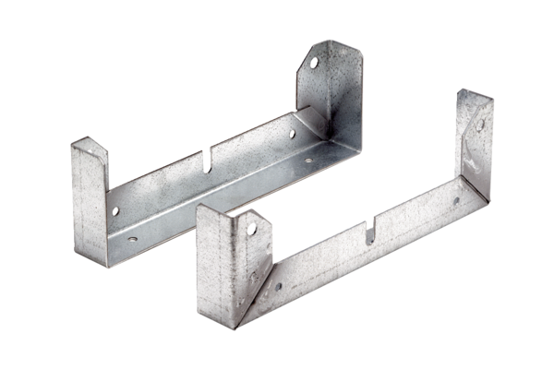Mounting foot FU 50Packing unit: 2 piecesRange: C
Article number: 0036.0075Manufacturer: MAICO

