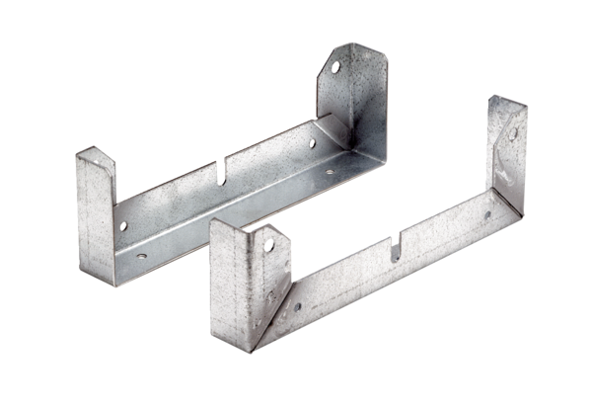Mounting foot FU 60Packing unit: 2 piecesRange: C
Article number: 0036.0077Manufacturer: MAICO

