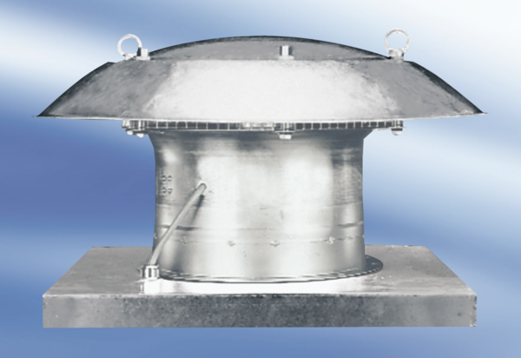Axial roof fan DZD 35/6 APacking unit: 1 pieceRange:
Article number: 0087.0417Manufacturer: MAICO

