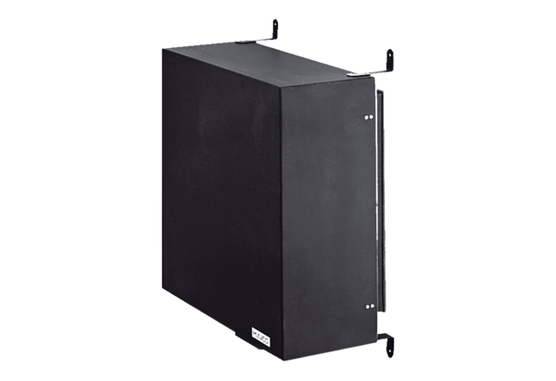Dark room attachment ZDK 25Packing unit: 1 pieceRange: C
Article number: 0093.0350Manufacturer: MAICO

