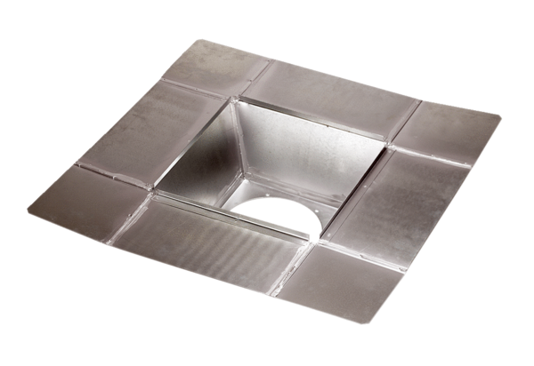Intermediate socket SZ 18Packing unit: 1 pieceRange: C
Article number: 0092.0286Manufacturer: MAICO

