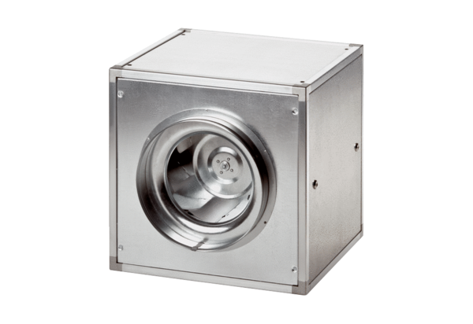Quickbox DSQ 45/6Packing unit: 1 pieceRange: C
Article number: 0080.0037Manufacturer: MAICO

