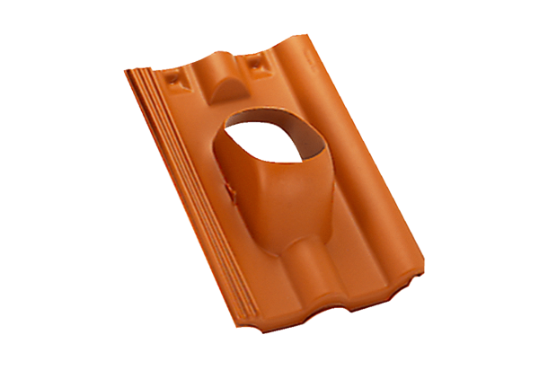Roofing tile DP 125 TFPacking unit: 1 pieceRange: B
Article number: 0092.0376Manufacturer: MAICO

