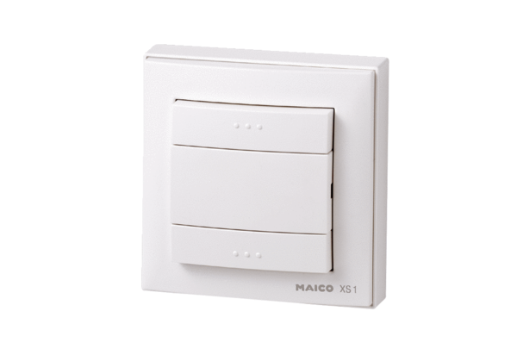Radio switch XS 1Packing unit: 1 pieceRange: C
Article number: 0157.0344Manufacturer: MAICO

