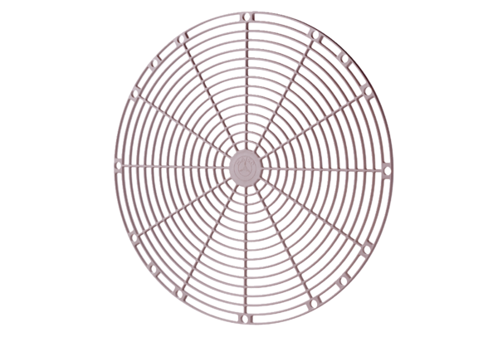Protective grille, synthetic material SGK 30Packing unit: 1 pieceRange: C
Article number: 0059.0163Manufacturer: MAICO

