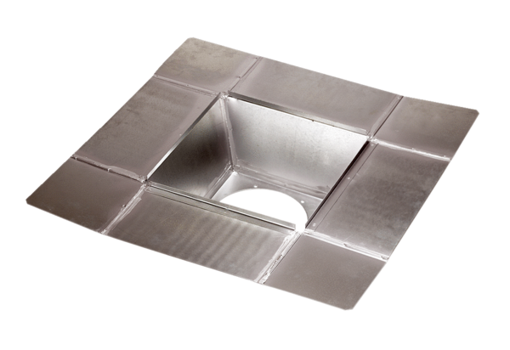Intermediate socket SZ 45Packing unit: 1 pieceRange: C
Article number: 0092.0292Manufacturer: MAICO

