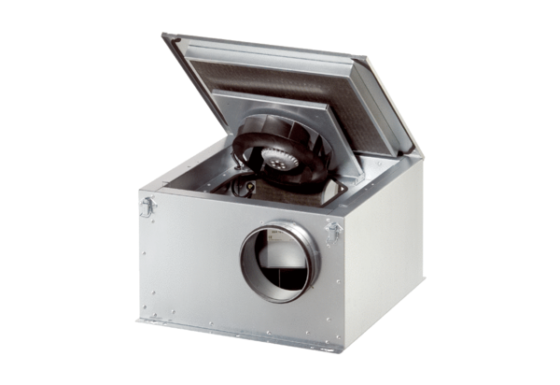Sound-insulated ventilation box ESR 31-2 SPacking unit: 1 pieceRange: C
Article number: 0080.0621Manufacturer: MAICO

