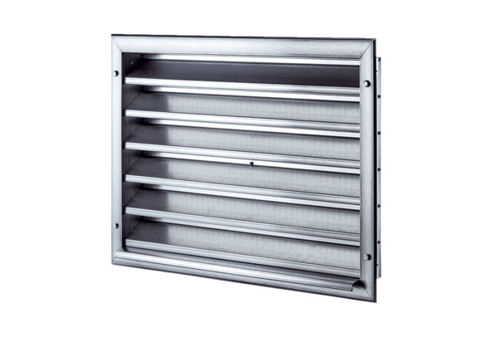External grille LZP 35Packing unit: 1 pieceRange: D
Article number: 0151.0259Manufacturer: MAICO

