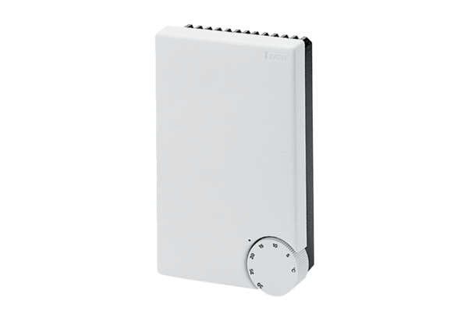Temperature control system ETL 16 PPacking unit: 1 pieceRange: C
Article number: 0157.0824Manufacturer: MAICO

